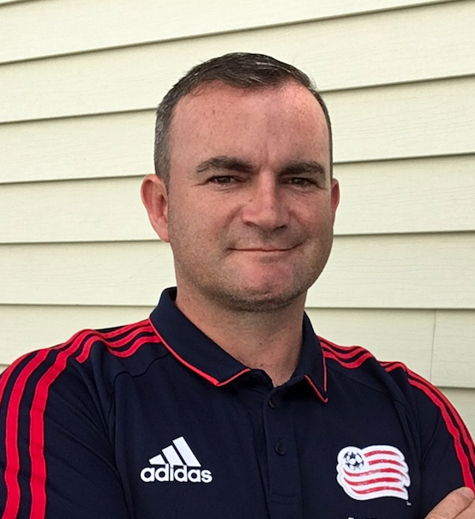

**OBJECTIVE**

**KEVIN FRIEL**

**Technical Coordinator**

**Joined Revs 2008**

**PHOTO HERE**

**My goal is to educate players with the knowledge they need to develop their game to their maximum potential. I want to connect with Players, Parents and Coaches across the NE Region inspiring each person and program to be the best they can be. My goal is to teach life lessons using soccer that players can use moving forward in sporting and non sporting endeavors.**

**COACHING EXPERIENCE**

* **Revolution 2: Equipment Specialist (2020)**
* **NE Revolution academy (2008-present)**
* **Sudbury YS Asst Tech Director (2008-2018)**
* **NE Revolution Youth teams (2010-2012)**
* **Strikers United (2008-2009)**
* **Beverly High School (1995-2005)**
* **Fanad United (Ireland) (1992-1995)**

**Email**

**KevinF@revolutionsoccer.net**

**Born and raised in**

**Co Donegal Ireland.**

**Now resides in Beverly MA**

**Playing Experience**

**Loreto College Milford (Ireland)**

**Fanad United (Ireland)**

**REVS COACHING ROLES**

* **PDP Programs – Lead coach**
* **NE Revolution Youth teams – Asst coach**
* **RDS Programs – Lead coach**
* **Residential Programs – Lead coach**
* **Sponsor events – Lead coach**
* **Head of game day promotions**
* **Youth team scout**

**CAREER HIGHLIGHTS**

* **14th season with New England Revolution**
* **Worked with first ever NE Revolution youth teams in USDA**
* **Played in USL, FAI Cup and Intermediate cup**



**EDUCATION**

* **Loreto College Milford (Ireland)**
* **Milford Technical College (Ireland)**
* **USSF Licensed coach**
* **NSCAA Advanced National**
* **FAI Level 1-5**

**LICENSING**